Experiments in Physics (experiment is modified version of experiment from PhET Simulations website
Inquiry Lab – Newton’s Universal Law of Gravitation – PhET simulation
Name________________________Score________________

Introduction: An interesting aspect of our universe is that anything that has mass has a gravitational pull. In other words, masses “attract” other masses by pulling on each other. Isaac Newton realized that the pull created by masses, known as gravity, applied to all masses including small objects, like apples, and large celestial objects, like the Moon and the Earth. In 1687 Newton discovered the mathematical relationship that exits between masses. The relationship that Newton’s discovered is one of the most important relationships in Physics and has helped humans put satellites into orbit and understand the motion of the planets in the solar system. The purpose of this lab is to discover the relationship that exists between masses known as Newton’s Universal Law of Gravitation.

Instructions:
- Find and open the PhET simulation entitled, “Gravity Force Lab”. ( https://phet.colorado.edu/ )
- Complete the tables below by changing the various settings. Note: Record the values for force in scientific notation and to 2 significant figures. Move the meter stick to measure the distance between the center of mass 1 to the center of mass 2. See the pictures on the right for each table.
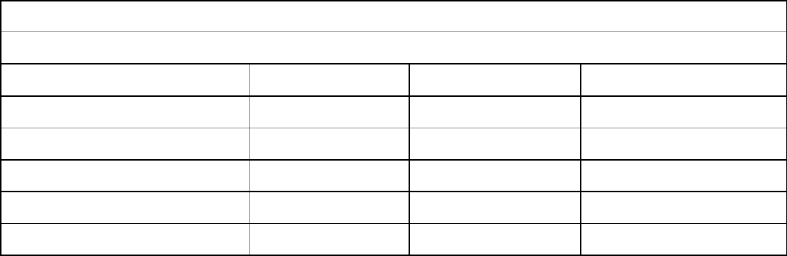
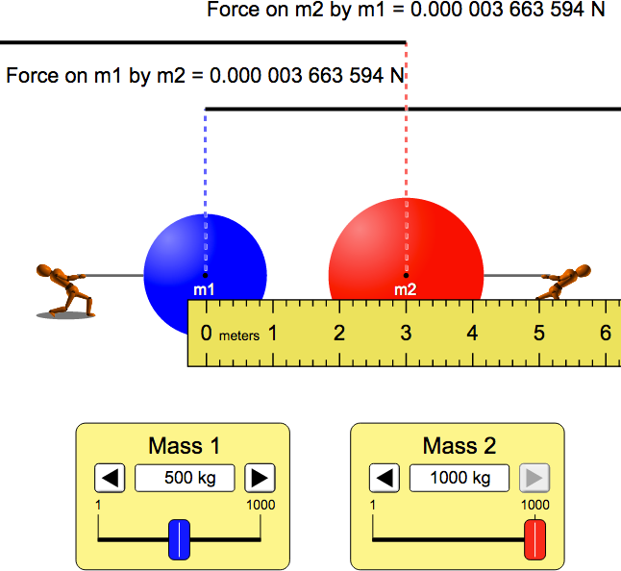
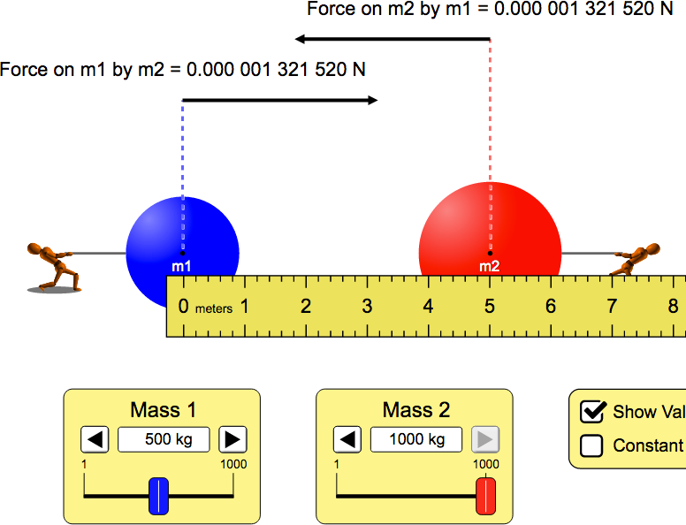
What is the relationship between F and r?
Table 1 – Varying r, the distance between the masses
What is the relationship between F and m₁?
Table 2 – Varying the mass of m₁

Force = F₁ = F₂ (N) | m₁ ( kg) | m₂ (kg) | r (m)
 | 500 | 1000 | 3
 | 500 | 1000 | 4
 | 500 | 1000 | 5
 | 500 | 1000 | 6
 | 500 | 1000 | 7

Force = F₁ = F₂ (N) | m₁ ( kg) | m₂ (kg) | r (m)
 | 500 | 1000 | 5
 | 600 | 1000 | 5
 | 700 | 1000 | 5
 | 800 | 1000 | 5
 | 900 | 1000 | 5

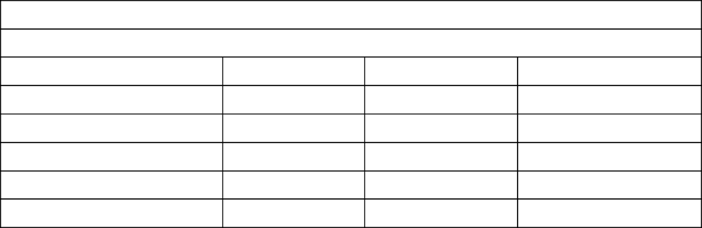
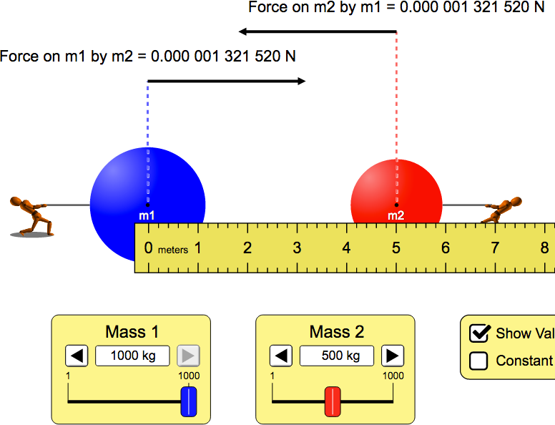

What is the relationship between F and m₂?
Table 3 – Varying the mass of m₂

Force = F₁ = F₂ (N) | m₁ ( kg) | m₂ (kg) | r (m)
 | 1000 | 500 | 5
 | 1000 | 600 | 5
 | 1000 | 700 | 5
 | 1000 | 800 | 5
 | 1000 | 900 | 5

(3) Construct 3 plots from the data above. Two plots should be linear and the other should be nonlinear. Copy (capture) plots and include below.

Questions
- Explain why varying the second mass had the same effect on the force as varying the first mass.

- What is the relationship (proportionality) between mass and force? What happens to the force if you double the mass of the blue object? What happens to the force if you then triple the red object’s mass?

- What is the relationship between distance and the force of gravity? What happens if you triple the distance between the objects? Half the distance between them?

- The Sun has a diameter of approximately 1,400,000 km. By how much would its gravity increase at its surface (assuming the sun had a surface) if the sun’s diameter were to shrink in size to 14,000 km (roughly the size of the Earth’s diameter). Show work. Remember, the force of gravity is an inverse square relationship.

